Marketing Proposal

Client Info:

<<Client Name>>

<<Client Number>>

<<Client Email>>

1

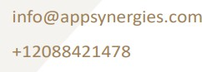

+12088421478

[www.appsynergies.com](http://www.appsynergies.com/) [info@appsynergies.com](mailto:info@appsynergies.com)

AppSynergies Pvt Ltd, D-1602, Orchid Suburbia, Link Road, Kandivali West, Mumbai 400067, India

186 Malvern Avenue, Harrow, HA2 9HD, UK

Increasing Visibility and Influence Through Digital Marketing Strategies

Table of Contents

* Company Overview 3
* Our Services 4
* Our Approach 6
* Team Expertise 7
* Business Requirements & Project Overview 8
* Project Pricing 16
* Project Timeline 18
* Client Onboarding 19
* Terms & Conditions 20
* Client Testimonials 21
* Case Studies 22
* Contact Us 24



# Company Overview

###### Why Us?

|  |  |  |  |  |
| --- | --- | --- | --- | --- |
| **30k+** | **1B+** | **150+** | **100+** | **95%** |
| **Leads** | **Impressions** | **Marketing** | **Happy** | **Satisfied** |
| **Generated** | **Created** | **Projects** | **Clients** | **Clients** |

|  |  |  |  |  |
| --- | --- | --- | --- | --- |
| Best Digital Marketing | Genuine White Hat | Highest Leads Achieved | No.1 Performance | Best Ecommerce |
| Agency | SEO Service | By An Agency | Marketing Agency | Marketing Campaign |
| Awarded by IIM Skill | Awarded by GoodFirms | Awarded by 3 Best Rated | Awarded by EZ Rankings | Awarded by Silicon India |



4



About Us

Driving Growth Through Technology and Marketing. We help businesses thrive in the digital landscape. From crafting innovative AI-driven apps and websites to executing high-impact SEO, ASO, SMM, content, and email marketing strategies, we deliver measurable results that matter.

We specialize in Design, Development, Testing, Release & Project Management of AI driven apps & websites. We also specialize in Digital Marketing Services like SEO, ASO, SMM, Content & Email Marketing.

Mission

To be a part of people's daily lives by helping them build lasting relationships in an environment of trust & respect.

Vision

To be one of the leading technology & marketing companies in the world,

admired for its innovative products & services thereby contributing to a better & sustainable world.

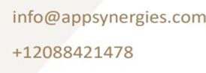

## Our Services



Digital Marketing

We are an AI driven digital marketing agency empowering your business to innovate, optimize & grow in your market using AI-fuelled marketing strategies. Our team of experts has over 5 years of experience in the digital marketing industry.

SEO

Social Media Marketing Content Marketing

PPC Advertising

Email Marketing Influencer Marketing

Manual & AI Sales Service

AI Automations

At AppSynergies, we help you to transform your business with AI & drive growth. Automate repetitive tasks, boost productivity, and make smarter decisions with our powerful AI solutions!

AI Calling Chatbots

Make Automations GHL Automations

ManyChat Automations

App Design & Development

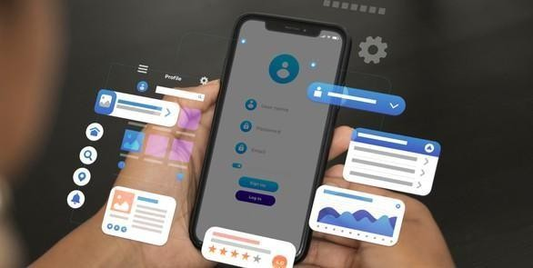

At AppSynergies, we build well-designed and optimized custom mobile applications with a delightful UX for both iOS and Android.

iOS Android Flutter

React JS Firebase

Website Design & Development

At AppSynergies, we offer a complete range of website services that build up business value, from the initial idea and formulation of product strategy, through building a prototype and testing it with users, right to the creation of the product itself.

Custom Website Design

E-Commerce Development Responsive Web Design Content Management System (CMS) Web Maintenance & Support

## Our Approach

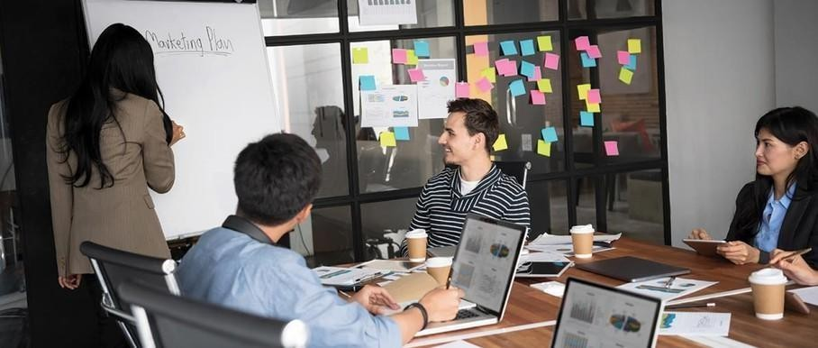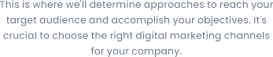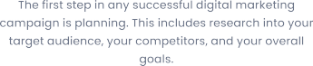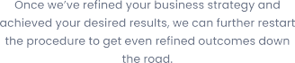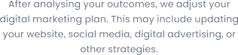

#### Digital Services

We begin by researching your industry and audience to create a tailored strategy. Our creative team crafts visually stunning posts. We implement marketing strategies to increase your online visibility.

## Team Expertise



Our team comprises of experts in various technical & marketing fields with approximately 5 - 10 years of experience & knowledge in delivering complex projects.

You will have the below list of experienced professionals working on your project:

* Digital Marketing Executive - <<DME>>
* Digital Marketing Associate - <<DMA>>
* Business Analyst – <<BA>>
* Graphics Designer - <<GD>>

### Business Requirement & Project Overview



Marketing Strategy:

1. **Market Analysis:** We will conduct extensive market research to understand the dynamics of industry, including current trends, growth opportunities and challenges.
2. **Niche Analysis:** We will analyse niche markets within the industry where you can establish a unique selling proposition (USP) and cater to specific consumer needs that are currently underserved by competitors.
3. **Competitor Analysis:** We will identify and analyse key competitors in the sector, examining their offerings, pricing strategies, marketing tactics and customer engagement methods.
4. **SWOT Analysis:** We will perform a SWOT (Strengths, Weaknesses, Opportunities, Threats) analysis for each competitor to identify gaps and opportunities that you can leverage to gain a competitive advantage.

Setting & Optimizing Social Media Channels:

1. **Profile Setup & Optimization:** We will ensure each profile includes relevant business information, high-quality brand visuals (logo, cover photo) and compelling bio that communicates your business’s value proposition and encourages engagement.

Setting Meta Ads Manager Account:

1. **Account Creation & Setup:** We will create a Meta Business Suite account. We will also set up the Meta Ads Manager Account, connecting it to the correct Business Suite Profile.
2. **Payment Method Setup:** We will guide you to add and verify a payment to ensure smooth processing of ad spend.
3. **Pixel & Conversion Tracking Setup:** We will install Meta Pixel on your website to track user activity and conversion events.

Setting Google Ads Manager Account:

1. **Account Creation & Setup:** We will create a Google Ads Manager account with accurate business details.
2. **Payment Method Setup:** We will guide you to add and verify a payment to ensure smooth processing of ad spend.
3. **Pixel & Conversion Tracking Setup:** We will install Google Ads conversion tracking tag on your website to track user activity and conversion events.

Creative Posts:

1. **Content Research:** We will conduct thorough research on your business, target audience preferences and content trends.
2. **Content Theme Identification:** We will identify key content themes aligned with your business’s brand identity, offerings, and business objectives.
3. **Social Media Captions Preparation:** We will develop compelling captions that resonate with your audience, incorporating brand voice, storytelling elements and CTAs to encourage engagement and interaction.
4. **Hashtags Research:** We will research and select relevant hashtags to increase discoverability and reach on each platform. We will use a mix of industry-specific, trending and branded hashtags to expand your social media reach.
5. **Content Calendar Preparation:** We will create a detailed content calendar outlining daily posts across Facebook, Instagram.
6. **Design Creatives (10 Posts Per Month):** We will design visually appealing creatives for 10 posts per month using graphic design tools and templates.
7. **Continuous Optimization:** We will conduct regular reviews of social media performance metrics, analyse competitor activities and stay updated with industry trends to refine your business’s social media strategy.

Meta Advertising Campaign:

1. **Campaign Objectives Identification:** We will define clear and specific campaign objectives aligned with your business goals. Campaign objectives may differ according to our advertising strategy.
2. **Conversion & Performance Goals:** We will establish measurable conversion and performance goals to track the success of ad campaigns. We will define key performance indicators (KPIs) such as conversion rates, cost per acquisition (CPA), return on ad spend (ROAS) and click-through rates (CTR) to gauge campaign effectiveness.
3. **Budget Allocation & Timeline:** We will allocate budget resources based on campaign objectives, target audience size and desired reach. We will also define campaign duration and scheduling for ad placements to optimize ad spend.
4. **Target Audience Analysis:** We will conduct audience research to define target demographics, interests and behaviours that align with your business’s ideal customer profile. We will utilize platform- specific targeting options (demographics, interests, behaviours) to segment and reach the most relevant audience for the campaign.
5. **Creating Ad Creatives:** Our design team will design ad visuals including images, videos, animations, or graphics that align with your brand guidelines and resonate with the target audience.
6. **Optimizing Primary Text, Headlines, Descriptions & CTA:** We will optimize ad copy elements such as primary text, headlines, descriptions and call-to-action (CTA) buttons to enhance ad relevance and drive desired actions.
7. **Monitoring Ads Performance:** We will monitor ad performance metrics in real-time and analyse data insights provided by platform analytics tools.
8. **Campaign Optimization:** We will implement continuous optimization techniques such as A/B testing of ad creatives, adjusting audience targeting, modifying bidding strategies and refining ad placements to improve campaign performance.

Google Advertising Campaign:

1. **Campaign Objectives Identification:** We will define clear and specific campaign objectives aligned with your business goals. Campaign objectives may differ according to our advertising strategy.
2. **Conversion & Performance Goals:** We will establish measurable conversion and performance goals to track the success of ad campaigns. We will define key performance indicators (KPIs) such as conversion rates, cost per acquisition (CPA), return on ad spend (ROAS) and click-through rates (CTR) to gauge campaign effectiveness.
3. **Budget Allocation & Timeline:** We will allocate budget resources based on campaign objectives, target audience size and desired reach. We will also define campaign duration and scheduling for ad placements to optimize ad spend.
4. **Keyword Research & Targeting:** We will conduct keyword research using Google Ads tools to identify high-performing and relevant keywords.
5. **Target Audience Analysis:** We will analyse your ideal customer profile to define target demographics, locations, interests, and online behaviour patterns.
6. **Creating Ad Creatives:** We will develop high quality and engaging ad creatives including responsive search ads, display banners and video ads.
7. **Optimizing Headlines, Descriptions, & Ad Extensions:** We will craft compelling ad copy, including attention-grabbing headlines and persuasive descriptions, to drive user engagement. Ad extensions such as sitelinks, callouts, and structured snippets will be optimized to provide additional information and enhance the visibility of your ads.
8. **Monitoring Campaign Performance:** We will monitor key metrics in real time using Google Ads’ analytics dashboard. Performance data, such as impressions, clicks, and conversions, will be reviewed regularly to identify trends, issues, and opportunities for improvement.
9. **Campaign Optimization:** Continuous optimization strategies will be implemented, including A/B testing for ad creatives, refining keyword targeting, and adjusting bids to achieve the best results.

SEO:

1. **Keyword Research:**
   * Identifying your target audience and their search intent.
   * Analysing competitor websites to identify keywords they are ranking for.
   * Finding keywords with high search volume and low competition.
   * Finding long-tail keywords for the website.
2. **Technical SEO:**
   * Ensuring the website has an SSL certificate (https).
   * Creating and submitting an XML sitemap to Google Search Console.
   * Reviewing and updating the robots.txt file.
   * Ensuring the website is mobile-friendly.
   * Redirecting 404 error pages to relevant content.
   * Using canonical tags to avoid duplicate content issues.
   * Optimizing page load time of the website.
   * Setting up and regularly monitoring Google Search Console.
   * Setting up and regularly monitoring Google Analytics.
3. **On-Page SEO:**
   * Optimizing existing and creating new high-quality content.
   * Ensuring clean and descriptive URL structures with keywords.
   * Ensuring each page has a unique and keyword-rich title tag.
   * Writing compelling meta descriptions with relevant keywords.
   * Using Heading tags to structure content and include keywords.
   * Maintaining a natural keyword density within content.
   * Optimizing images by using descriptive names and alt tags.
   * Creating logical internal and external linking.
4. **Off-Page SEO:**
   * Auditing your existing backlinks.
   * Disavowing toxic or irrelevant backlinks.
   * Building high-quality backlinks to the website.
   * Submitting the website to relevant directories and listings.
5. **SEO Audit:**
   * Performing periodic SEO Audits to identify new issues and opportunities.

Email Marketing (Mailchimp):

1. **Campaign Strategy & Objective Setting:** We will define the purpose and objectives of your email marketing campaign, nurturing leads, promoting a new package, or driving website traffic. Each campaign will be aligned with your broader business goals, ensuring a strategic approach to engaging your target audience. Campaign objectives may differ according to our advertising strategy.
2. **Template Design & Content Creation:** We will create visually appealing and responsive email templates in Mailchimp that reflect your brand identity. High-quality content, including attention- grabbing subject lines, persuasive copy, and clear calls-to-action (CTAs), will be developed to encourage recipient engagement and drive conversions.
3. **Email Automation Setup:** Automation workflows will be designed and implemented to deliver personalized and timely emails based on subscriber behaviour.
4. **Campaign Testing & Optimization:** Before launching, each email will undergo rigorous testing for design, layout, and functionality on different devices and email clients. A/B testing of subject lines, CTAs, and visuals will be conducted to identify the most effective elements and improve overall campaign performance.

Monthly Maintenance & Reporting:

1. **Campaign Summary Preparation:** We will compile a comprehensive summary of campaign performance for the reporting period.
2. **Ad Performance Analysis:** We will analyse detailed ad performance metrics to assess effectiveness and impact. We will provide an overview of key metrics including reach, impressions, engagement rates, leads conversions and CPC.

## Project Pricing

|  |  |  |  |
| --- | --- | --- | --- |
| **Description** | **Task** | **Pricing** | **Type** |
| Marketing Strategy | Research & Plan Timelines | <<MS>> | One Time Fee |
| Set up Social Media handles | Optimization, Integration, Setup | <<SM>> | One Time Fee |
| Set up Meta & Google Ads Manager | Integration, Setup | <<MG>> | One Time Fee |
| Creative Posts (10 per month) | Content, Calendar, Creatives, Research | <<CP>> | Monthly Recurring Fee |
| Meta Paid Ads | Admin cost to run & manage ads | <<MP>> | Monthly Recurring Fee |
| Google Paid Ads | Admin cost to run & manage ads | <<GP>> | Monthly Recurring Fee |
| SEO | Website Optimization | <<SEO>> | Monthly Recurring Fee |
| Email Marketing | Mailchimp (500 Emails) | <<EM>> | Monthly Recurring Fee |
| Monthly maintenance & Reporting | Social media reporting and ads reporting | <<MR>> | Monthly Recurring Fee |



|  |  |
| --- | --- |
| **Total Marketing Cost** | **<<Total>>** |
| **GST** | **<<GST>>** |
| **Total Price** | **<<TP>>** |

***Note****: The Ad Budget should be spent by you. You have to allocate the amount that you want to spend for the entire month.*

##### Payment Method

AppSynergies Pvt Ltd accepts the following payment method:

* + Bank Transfer
  + Credit Cards and Debit Cards
  + Net Banking
  + Gpay or Paytm

##### Payment Schedule

|  |  |  |
| --- | --- | --- |
| **Sr No.** | **Schedule** | **Amount** |
| 1 | Instalment 1 (Has to be paid before start of the project) - One-time fee | <<Instalment 1>> |
| 2 | Instalment 2 (Has to be paid once we set up the social media handles) - It’s a monthly recurring cost | <<Instalment 2>> |

**Note:** We are happy to offer 10% discount if you can sign the contract & start the project within 48 hours.

Next Steps:

Our proposal is valid for a week. To take advantage of this proposal and proceed with the project as outlined, the client next step must be to:

* + Accept the proposal as-is
  + Discuss desired changes with AppSynergies Pvt Ltd.
  + Finalize and sign the contract
  + Submit an initial payment as mentioned in the payment schedule section

Once completed, AppSynergies Pvt Ltd will connect you to schedule project launch meeting to make introductions and gather information before beginning the work.

We are happy to make changes to the project scope on your request at any time but this may be subject to additional billing.

## 

## Project Timeline

## 

* 3-5 Days Marketing Strategy
* 1-2 Days Social Media   
   Channel & Ad  
   Account Setup



* 3-5 Days Creative Posts  
   (10 per Month)



* 30 Days Paid Ads  
   (Meta + Google)
* 15 Days Email Marketing



* 30 Days SEO



* 30 Days Monthly Reporting

## Client Onboarding

18



* **Initial Consultation**: We schedule a meeting to discuss your goals, needs, and expectations.
* **Proposal Presentation**: We present our tailored proposal, including pricing and project details.
* **Project Kickoff**: Once you approve the proposal, we initiate the project, assigning a dedicated team.
* **Regular Updates**: We provide regular progress updates and milestones.
* **Project Completion**: Upon project completion, we conduct thorough testing and hand over all deliverables.
* **Ongoing Support**: We offer post-launch support and assistance as needed.

## Terms & Conditions



Once the project fee is paid in full to AppSynergies Pvt Ltd, any elements of text, graphics, photos, contents, trademarks, or other artwork furnished to the client for inclusion in the website are owned by the client. AppSynergies Pvt Ltd assumes the client has permission from the rightful owner to use any code, scripts, data, and reports provided by the client for inclusion in its materials, and will hold harmless, protect, and defend AppSynergies Pvt Ltd from any claim or suit arising from the use of such work.

AppSynergies Pvt Ltd retains the right to display graphics and other web content elements as examples of their work in their portfolio and as content features in other projects. This agreement becomes effective only when signed by the client and AppSynergies Pvt Ltd. Regardless of the place of signing of this agreement, the client agrees that for purposes of venue, this contract was entered into in Mumbai, India and any dispute will be litigated or arbitrated in Mumbai, India.

The agreement in this contract constitutes the sole agreement between the client and AppSynergies Pvt Ltd regarding all items included.

**This proposal shall be valid until <<VDate>>**

**Feel free to reach out to us at** [info@appsynergies.com](mailto:info@appsynergies.com) **or +91-9967067419 for any questions.**

**Signature Details**

Sneha Shukla

|  |  |
| --- | --- |
| <<Client Name>> | Sneha Shukla |
| <<Date>> | <<Date>> |

We look forward doing business with you.

Thank You, Team AppSynergies

## Client Testimonials

MingleWise



“Appsynergies has been instrumental in driving the growth of MingleWise’s app subscriptions. Their targeted digital marketing campaigns helped us enhance our social media presence, boost engagement, and achieve significant user acquisition. The team’s strategic approach and expertise delivered excellent results, making a notable impact on our business.”

Al Dar Physiotherapy Clinic

“Working with Appsynergies has greatly enhanced Aldar Physiotherapy Clinic’s online presence. Their strategic approach to digital marketing helped us increase patient inquiries, improve our local search visibility, and drive more traffic to our website. The team’s expertise in optimizing campaigns has resulted in a significant return on investment.

Highly recommended!”

Stylish-sara (E-Commerce)

“Appsynergies has been a cornerstone in establishing and growing Stylish Sara’s e-commerce business from the ground up. Their strategic digital marketing initiatives have helped us build a strong online presence, attract the right audience, and convert them into loyal customers. Their expertise and dedication have been instrumental in driving our business growth across the UAE and the US.”

Sohan Jewellers

“Appsynergies significantly boosted Sohan Jewellers’ Instagram presence and helped us attract a steady stream of high-quality leads. Their targeted campaigns and strategic approach enhanced our website traffic and delivered a strong return on

investment.”

Property Dictionary

“Appsynergies has played a pivotal role in the

growth of Sara Reality’s business. Their expertise in digital marketing helped us increase our online visibility and attract more qualified leads. Through their targeted campaigns and engaging content, we saw a remarkable transformation in how we connect with potential buyers and convert site visits into sales. The results speak for themselves, and we are extremely satisfied with the outcomes.”

Craft N Skill Studio

“Appsynergies has been a key partner in growing Craft N Skill Studio’s online presence. Their expertise in Instagram marketing helped us increase engagement, attract new followers, and generate a significant number of workshop inquiries. Their targeted campaigns and strategic approach led to a remarkable return on investment. Highly

recommended!”

## Case Studies

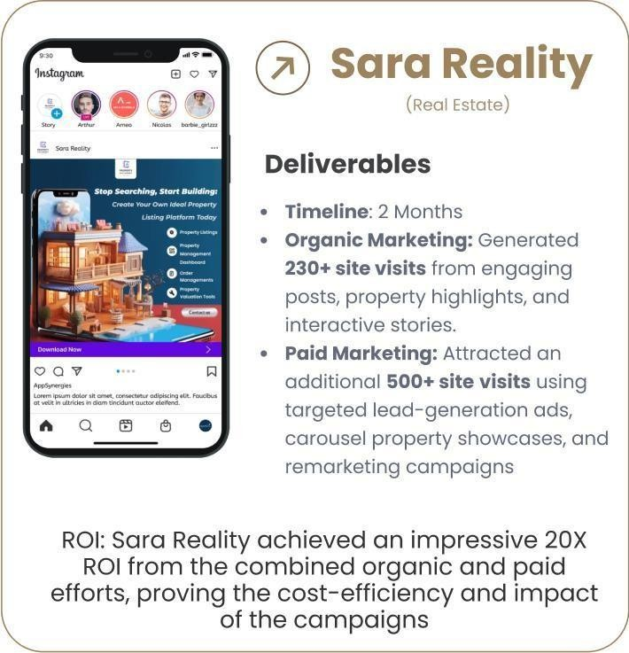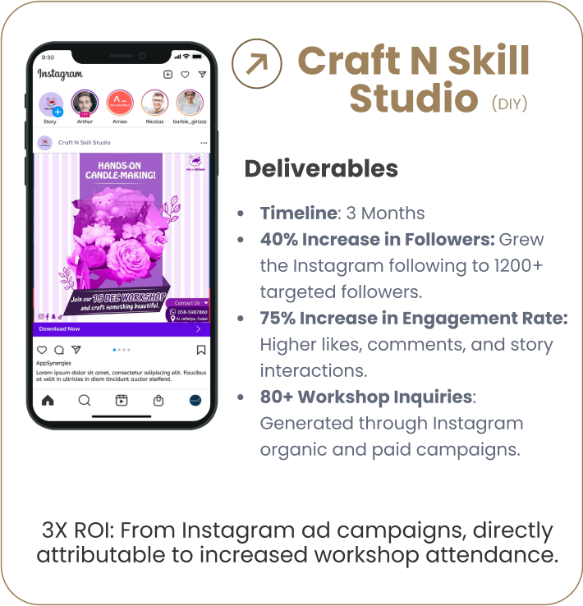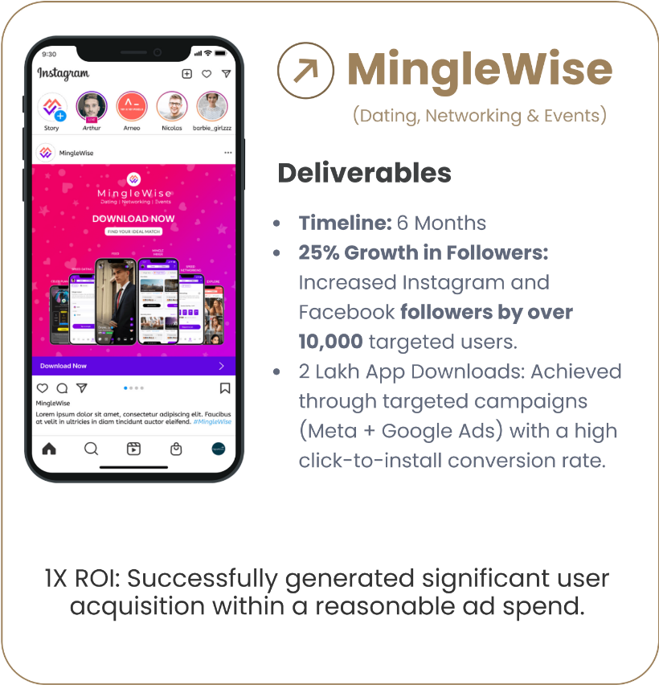





## Contact Us

Website <https://appsynergies.com/>

Phone +12088421478

E-Mail [info@appsynergies.com](mailto:info@appsynergies.com)

Social Media

Address 186 Malvern Avenue, Harrow, HA2 9HD, UK. D-1602, Orchid Suburbia, Link Road, Kandivali West, Mumbai 400067, India